

19ELC312 Database Systems and Programming

**Team Number:** 01

**Title:** Medical Record maintenance

**Group Members:**

AATHITHYA – CB.EN.U4ELC20001

SAI KRISHNA ACHANTA – CB.EN.U4ELC20004 VIMAL DHARSHAN – CB.EN.U4ELC20081

**ER DIAGRAM:**

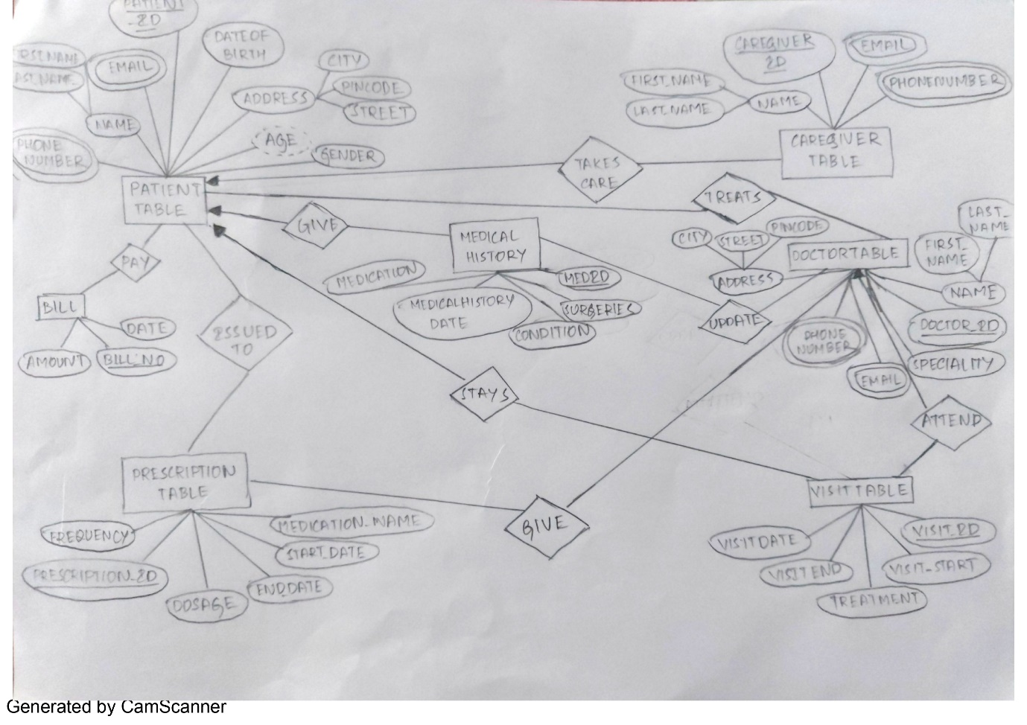

LIST OF ENTITIES = 7

* Patient table
* Caregiver table
* Prescription table
* Bill
* Visit table
* Doctor table
* Medical table

**RELATIONAL SCHEMA:**

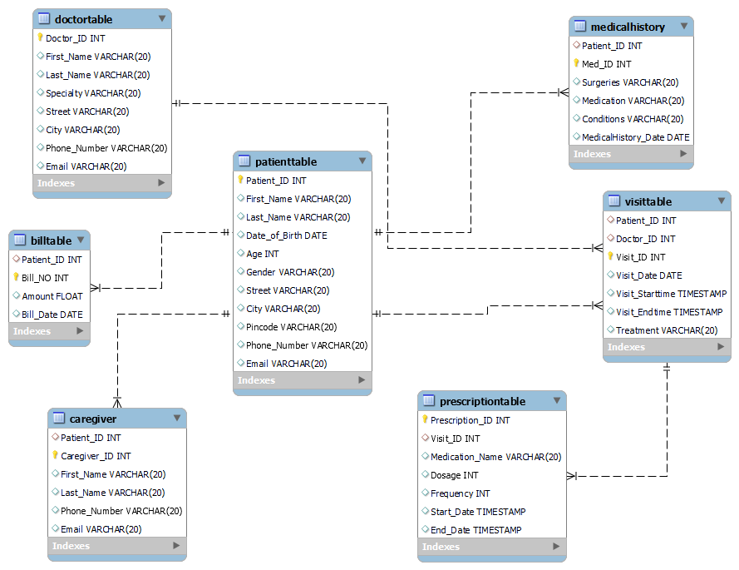

**LEGEND:**

Yellow Bulb – Primary Key

Faint Red Diamond – Foreign Key

Faint Blue Diamond – Attributes

* PatientTable(Patient_ID (primary key),First_Name,Last_Name,Date_of_Birth,Age,Gender,Street,City,Pincode,Phone_Number,Email)
* Caregiver Table (Patient_ID(foreign key referencing from patient table),Caregiver_ID(Primary key),First_Name,Last_Name,Phone_Number,Email)
* Medical History(Patient_ID(foreign key referencing from patient table),Med_ID(Primary key),Surgeries ,Medication, Conditions,Date.)
* Doctor Table(Doctor_ID (primary key),First_Name,Last_Name,Specialty,Address,Street,City,Phone_Number,Email)
* Visit Table(Visit_ID (primary key),Patient_ID (foreign key referencing Patient table),Doctor_ID (foreign key referencing Doctor table),Visit_Date,Visit_End time,Visit_Start time,Treatment)
* Prescription Table(Prescription_ID (primary key),Visit_ID (foreign key referencing Visit table),Medication_Name,Dosage,Frequency,Start_Date,End_Date)
* Bill(Patient_ID(foreign key referencing from patient table),Bill_NO(primary key),Amount,Bill_Date)

**SQL CODE:**

CREATE TABLE PatientTable (

Patient_ID INT PRIMARY KEY,

First_Name VARCHAR(20),

Last_Name VARCHAR(20),

Date_of_Birth DATE,

Age INT,

Gender VARCHAR(20),

Street VARCHAR(20),

City VARCHAR(20),

Pincode VARCHAR(20),

Phone_Number VARCHAR(20),

Email VARCHAR(20)

);

INSERT INTO PatientTable values(01,'Kural','Anbu',date '2002-07-21',20,'Male','3rd street','Coimbatore','641 615','9786542316','kural@gmail.com')

INSERT INTO PatientTable values(02,'Harish','S',date '2001-11-17',21,'Male','2nd street','Chennai','641 002','7806512239','harish007@gmail.com')

INSERT INTO PatientTable values(03,'Aathil','M',date '2003-04-09',20,'Male','2nd cross street','Salem','641 668','7129400632','aathil@gmail.com')

INSERT INTO PatientTable values(04,'Sai','Krishna',date '1999-06-27',23,'Male','Amrita street','Coimbatore','641 605','7080420158','saikrishna@gmail.com')

**RESULT:**

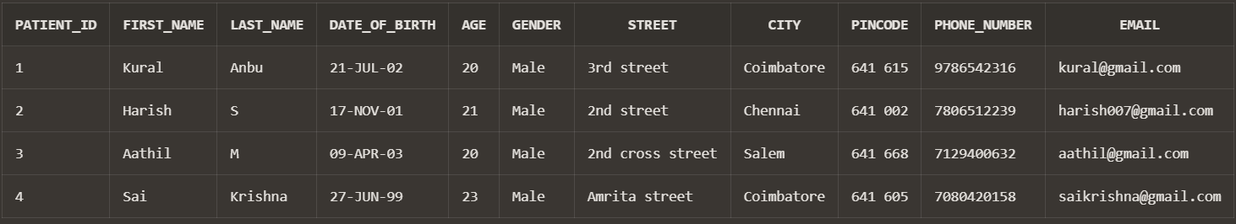

CREATE TABLE Caregiver (

Patient_ID INT,

Caregiver_ID INT PRIMARY KEY,

First_Name VARCHAR(20),

Last_Name VARCHAR(20),

Phone_Number VARCHAR(20),

Email VARCHAR(20),

FOREIGN KEY (Patient_ID) REFERENCES PatientTable(Patient_ID)

);

INSERT INTO Caregiver values(03,21,'Kavi','KP','9766818526','kavi@gamil.com')

INSERT INTO Caregiver values(01,22,'Sudarshan','S','9557102807','sudarshan@gamil.com')

INSERT INTO Caregiver values(02,23,'Nerik','S','7991460406','nerik@gamil.com')

INSERT INTO Caregiver values(04,24,'Anish','Krishna','9687933225','anish@gamil.com')

**RESULT:**

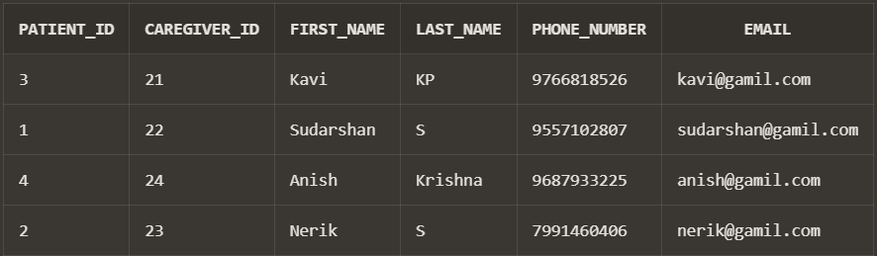

CREATE TABLE MedicalHistory (

Patient_ID INT,

Med_ID INT PRIMARY KEY,

Surgeries VARCHAR(20),

Medication VARCHAR(20),

Conditions VARCHAR(20),

MedicalHistory_Date DATE,

FOREIGN KEY (Patient_ID) REFERENCES PatientTable(Patient_ID)

);

INSERT INTO MedicalHistory VALUES(01,31, 'Bypass surgery', 'Metoprolol', 'Angina',date '2023-05-02');

INSERT INTO MedicalHistory VALUES(02,33,'Thyroidectomy', 'Levothyroxine', 'Thyroid disorder',date '2023-04-30');

INSERT INTO MedicalHistory VALUES(03,32, 'Chemotherapy', 'Tamoxifen', 'Breast cancer',date '2023-04-27');

INSERT INTO MedicalHistory VALUES(04,34,'Knee replacement', 'Ibuprofen', 'Joint pain',date '2023-04-29');

**RESULT:**

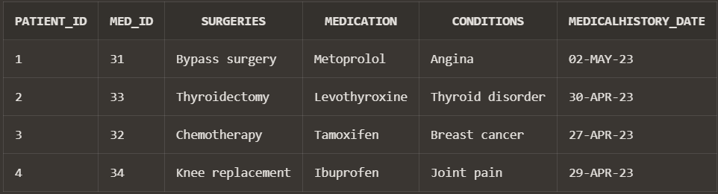

CREATE TABLE DoctorTable (

Doctor_ID INT PRIMARY KEY,

First_Name VARCHAR(20),

Last_Name VARCHAR(20),

Specialty VARCHAR(20),

Street VARCHAR(20),

City VARCHAR(20),

Phone_Number VARCHAR(20),

Email VARCHAR(20)

);

INSERT INTO DoctorTable VALUES (01, 'John', 'Smith', 'Cardiology', '123 Main St', 'Anytown', '555-1234', 'jsmith@example.com');

INSERT INTO DoctorTable VALUES (02, 'Sarah', 'Jones', 'Pediatrics', '456 Oak St', 'Othertown', '555-5678', 'sjones@example.com');

INSERT INTO DoctorTable VALUES (03, 'Michael', 'Nguyen', 'Dermatology', '789 Elm St', 'Somewhere', '555-2468', 'mnguyen@example.com');

INSERT INTO DoctorTable VALUES (04, 'Emily', 'Kim', 'Family Medicine', '10 Maple St', 'Anytown', '555-3698', 'ekim@example.com');

**RESULT:**

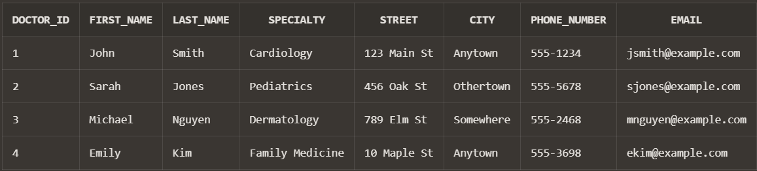

CREATE TABLE VisitTable (

Patient_ID INT,

Doctor_ID INT,

Visit_ID INT PRIMARY KEY,

Visit_Date DATE,

Visit_Starttime TIMESTAMP,

Visit_Endtime TIMESTAMP,

Treatment VARCHAR(20),

FOREIGN KEY (Patient_ID) REFERENCES PatientTable(Patient_ID),

FOREIGN KEY (Doctor_ID) REFERENCES DoctorTable(Doctor_ID)

);

INSERT INTO VisitTable VALUES(01,02,11,date '2023-05-01',TIMESTAMP'2023-05-01 13:00:00',TIMESTAMP'2023-05-01 14:00:00','Bypass surgery')

INSERT INTO VisitTable VALUES(02,03,12,date '2023-04-11',TIMESTAMP'2023-04-11 12:00:00',TIMESTAMP'2023-04-11 14:00:00','Thyroidectomy')

INSERT INTO VisitTable VALUES(03,04,13,date '2023-11-21',TIMESTAMP'2023-11-21 11:00:00',TIMESTAMP'2023-11-21 13:00:00','Chemotherapy')

INSERT INTO VisitTable VALUES(04,01,14,date '2023-01-12',TIMESTAMP'2023-01-12 09:00:00',TIMESTAMP'2023-01-12 12:00:00','Knee replacement')

**RESULT:**

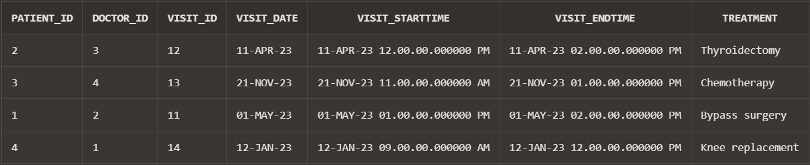

CREATE TABLE PrescriptionTable (

Prescription_ID INT PRIMARY KEY,

Visit_ID INT,

Medication_Name VARCHAR(20),

Dosage INT,

Frequency INT,

Start_Date TIMESTAMP,

End_Date TIMESTAMP,

FOREIGN KEY (Visit_ID) REFERENCES VisitTable(Visit_ID)

);

INSERT INTO PrescriptionTable VALUES (51, 11, 'Aspirin', 50, 2,TIMESTAMP '2023-05-01 08:00:00',TIMESTAMP '2023-05-05 08:00:00')

INSERT INTO PrescriptionTable VALUES (52, 12, 'Amoxicillin', 250, 3,TIMESTAMP '2023-04-28 09:00:00',TIMESTAMP '2023-05-03 09:00:00')

INSERT INTO PrescriptionTable VALUES (53, 13, 'Ibuprofen', 200, 1,TIMESTAMP '2023-05-01 12:00:00',TIMESTAMP '2023-05-04 12:00:00')

INSERT INTO PrescriptionTable VALUES (54, 14, 'Metformin', 500, 2,TIMESTAMP '2023-04-30 18:00:00',TIMESTAMP '2023-05-07 18:00:00')

**RESULT:**

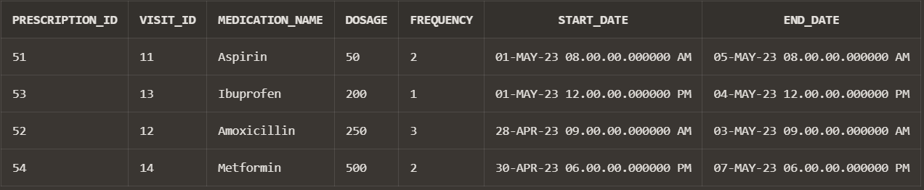

CREATE TABLE BillTable(

Patient_ID INT,

Bill_NO INT PRIMARY KEY,

Amount FLOAT,

Bill_Date DATE,

FOREIGN KEY (Patient_ID) REFERENCES PatientTable(Patient_ID)

);

INSERT INTO BillTable VALUES (01, 61, 150.50,date '2023-05-01')

INSERT INTO BillTable VALUES (04, 65, 750.25,date '2023-05-02')

INSERT INTO BillTable VALUES (02, 62, 2000.00,date '2023-04-28')

INSERT INTO BillTable VALUES (03, 69, 300.00,date '2023-05-03')

**RESULT:**

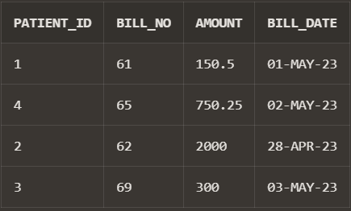

**SAMPLE QUERIES:**

**--TO PRINT VISIT TABLE:**

**QUERY:**

select *from VisitTable;

**RESULT:**

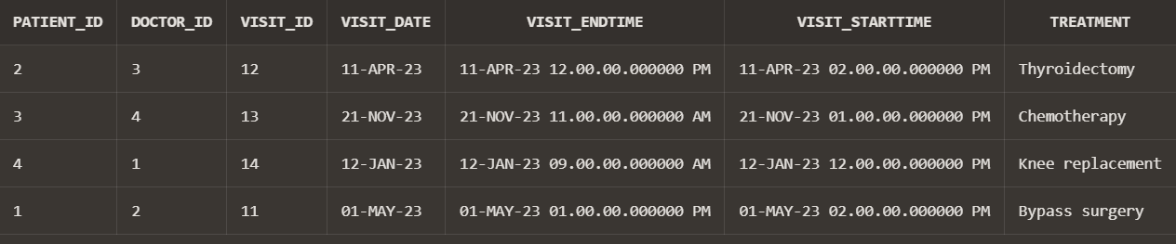

**--TO DISPLAY COUNT OF NUMBER OF PATIENTS:**

**QUERY:**

select COUNT(Patient_ID)from Patienttable;

**RESULT:**

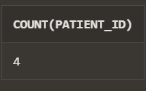

**--TO DISPLAY DETAILS OF PATIENTS AND DOCTOR:**

**QUERY:**

SELECT p.First_Name,d.First_Name

FROM PatientTable p

JOIN VisitTable v ON p.Patient_ID = v.Patient_ID

JOIN DoctorTable d ON v.Doctor_ID = d.Doctor_ID;

**RESULT:**

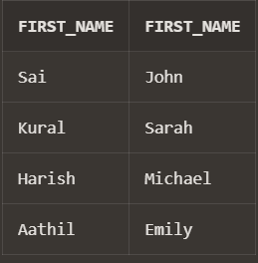

**--TO DISPLAY PATIENT DETAILS WHERE AGE GREATER THAN 20:**

**QUERY:**

SELECT * from PatientTable where Age>20;

**RESULT:**

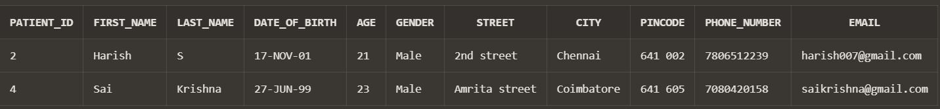

**--TO DISPLAY BILL DETAILS WHERE AMOUNT GREATER 500 AND BILL DATE LESS THAN 2023-05-01:**

**QUERY:**

SELECT *FROM BillTable WHERE Amount > 500 AND Bill_Date < DATE '2023-05-01';

**RESULT:**

